***Cucumber JVM with Maven***

***Add the following dependencies in the pom.xml:***

* **cucumber-junit(1.2.4)**
* **cucumber-java(1.2.4)**
* **cucumber-testng(1.2.4)**

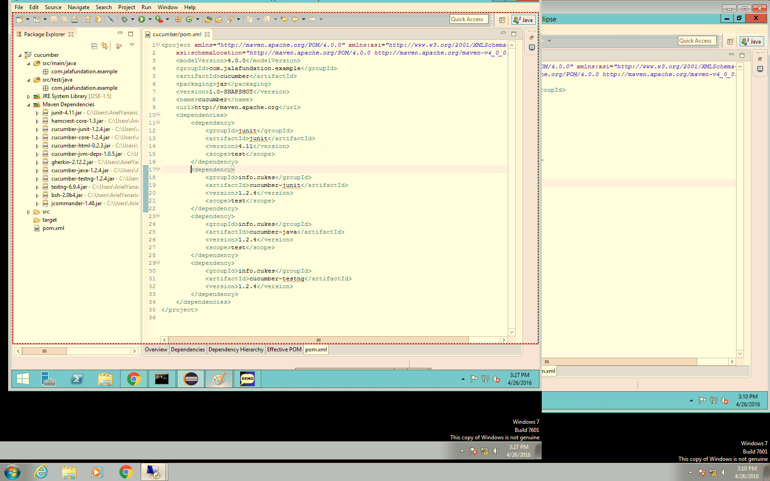

Note that the dependencies have been added.

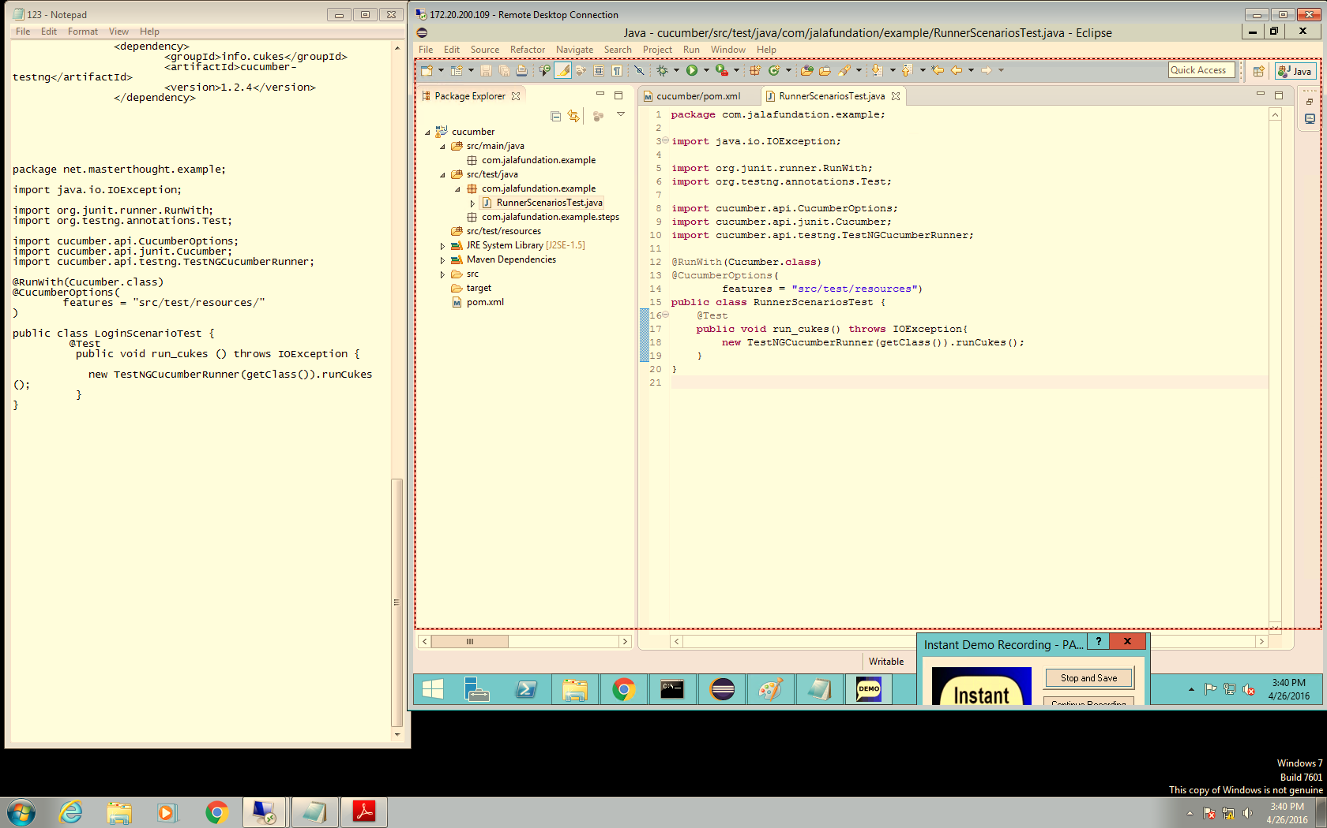

 Location of the feature file.

***Create a runner class RunScenariosTest which contains Cucumber execution parameters. Note that these can also be passed in command-line but we put them in the test for simplicity.***

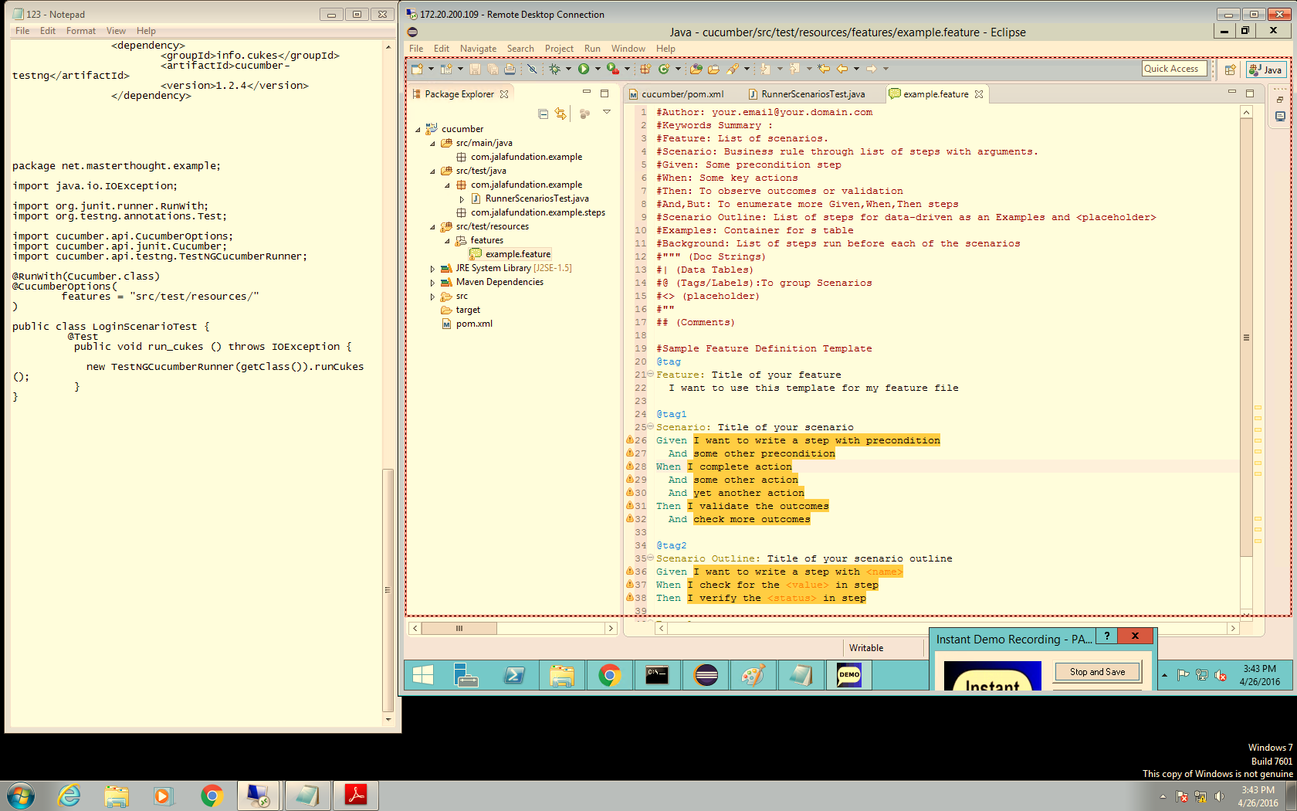

***Create cucumber feature (By default):***

***Line 25 : start a new scenario.***

***Lines 26-32 : scenario steps which are executed.***

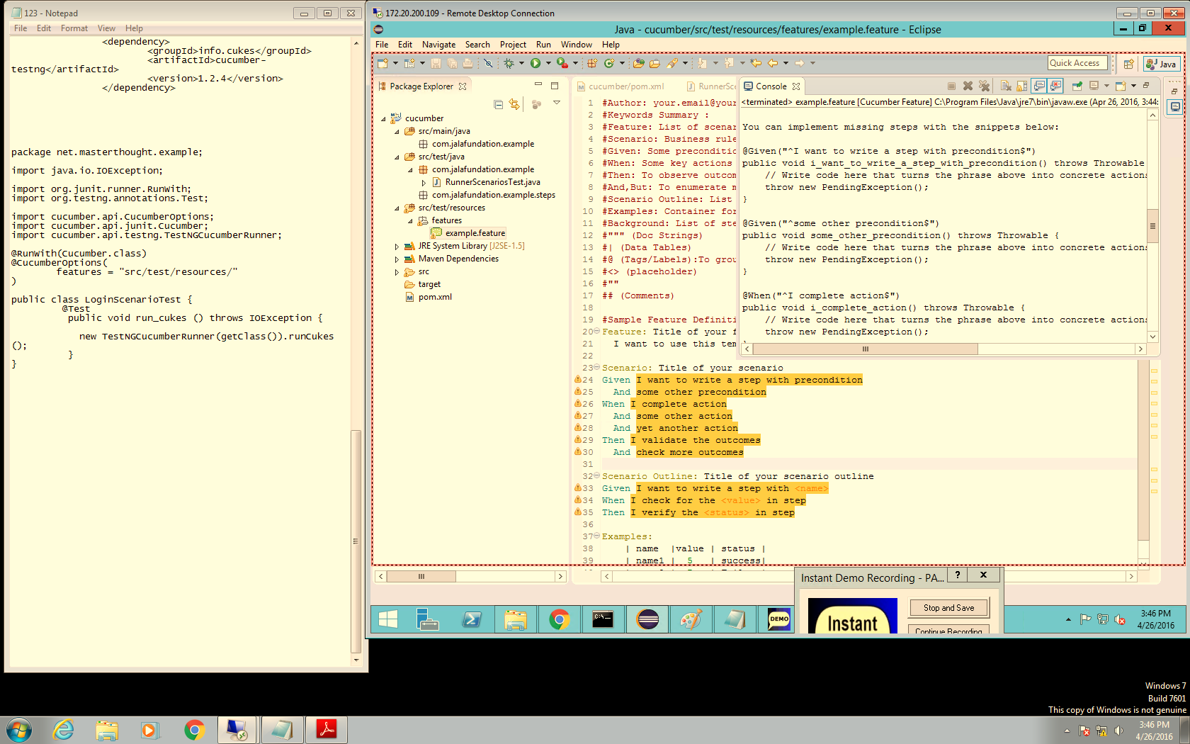

***Now run the cucumber feature that has been created using “cucumber plugin”.***

***The result will be displayed by console where the steps are reflected according the cucumber feature.***

***According the steps generated we can use these steps and just implement the code that we need like the following picture.***

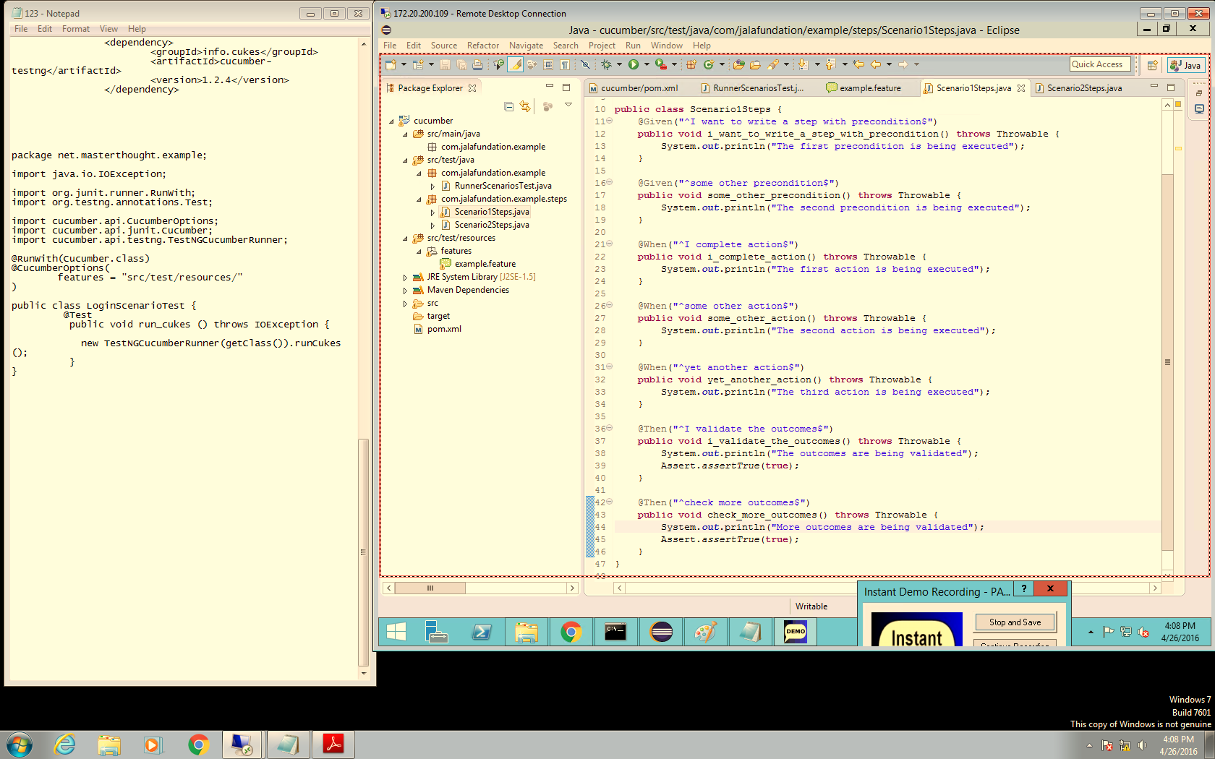

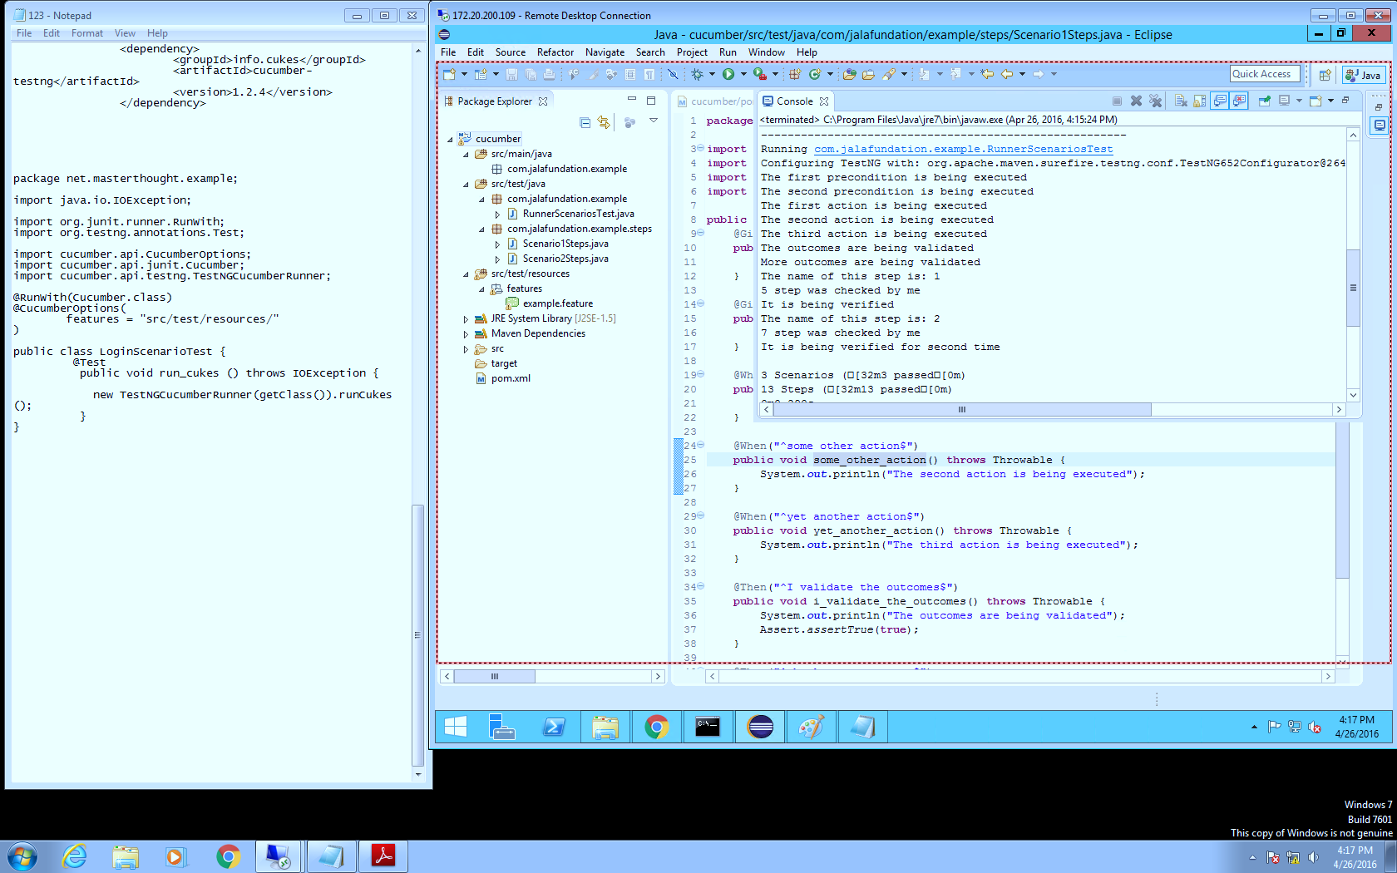

***When it scenario runs using maven (mvn test) the steps are displayed according the cucumber feature. We can see the scenario and understand the flow.***

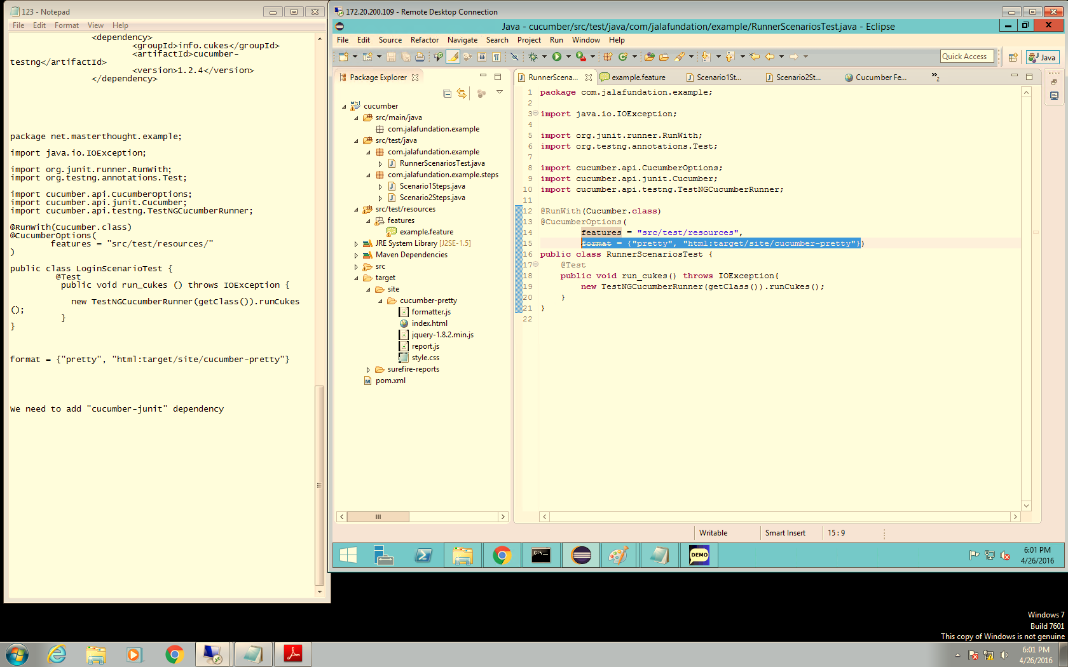

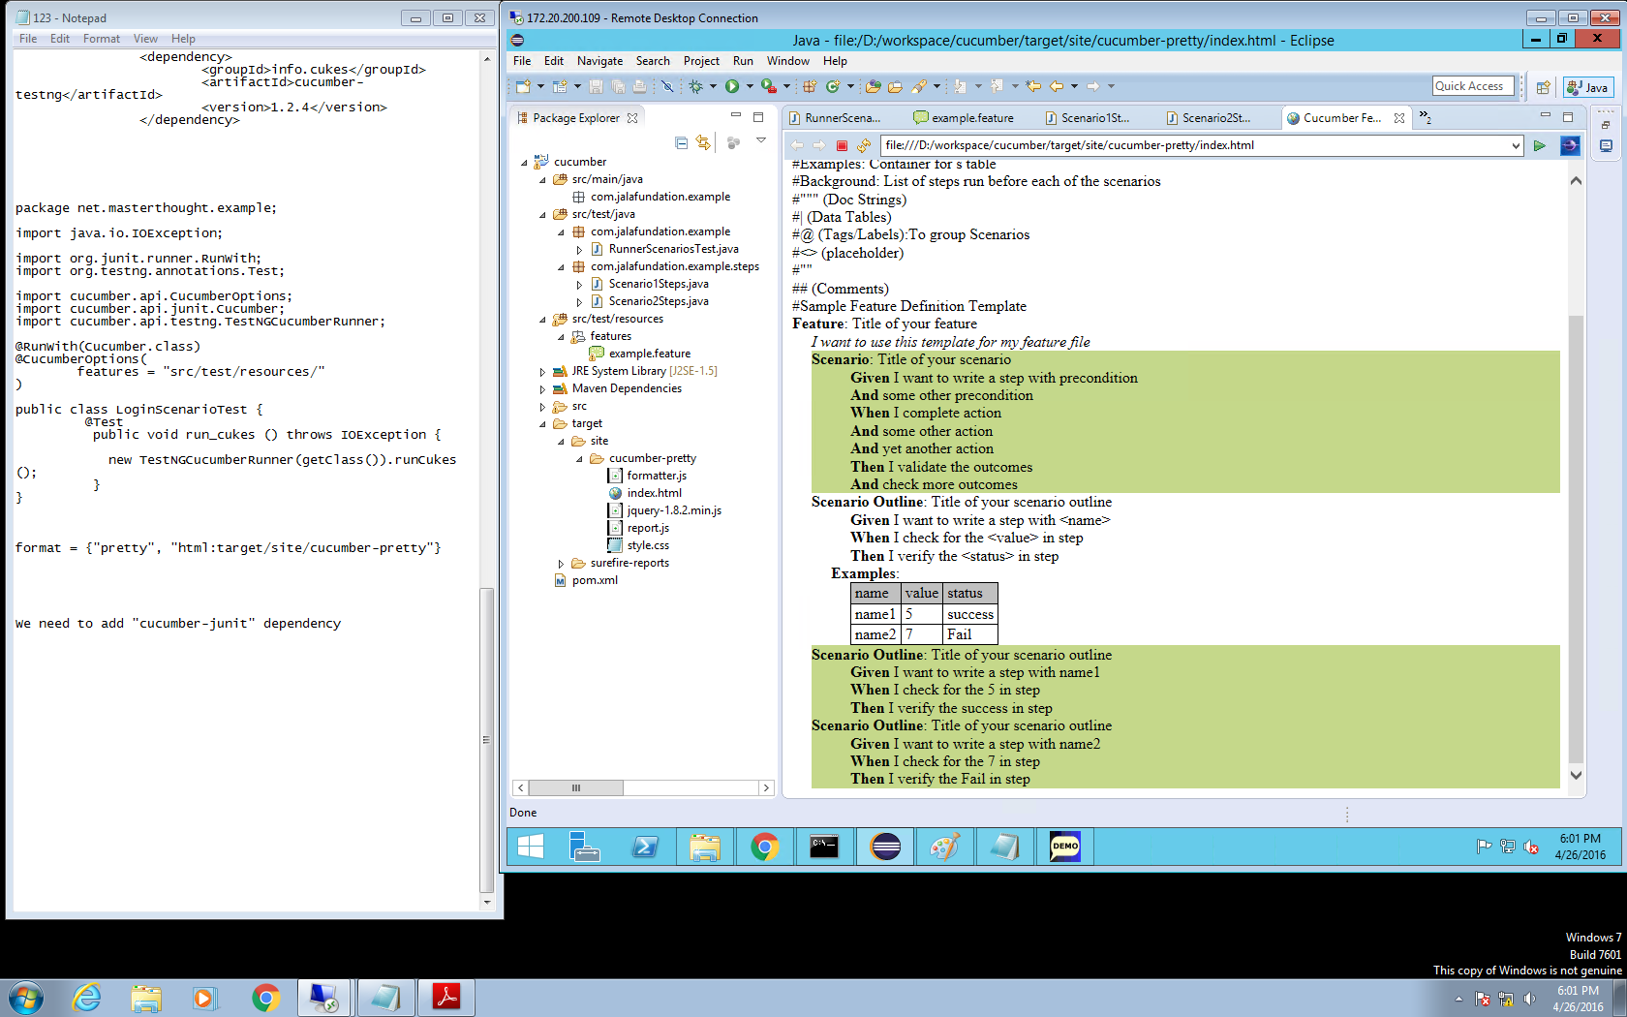

***Line 15 – pass on Cucumber options: output formatting for obtains a report.html.***

***The result will be like the picture.***